**ScienceQtech Employee Performance Mapping.**

Q1) Create a database named employee, then import data_science_team.csv proj_table.csv

and emp_record_table.csv

into the employee database from the given resources.

Ans) create database employee;

use employee;

show tables;

Q2) Create an ER diagram for the given **employee**database.

Ans)

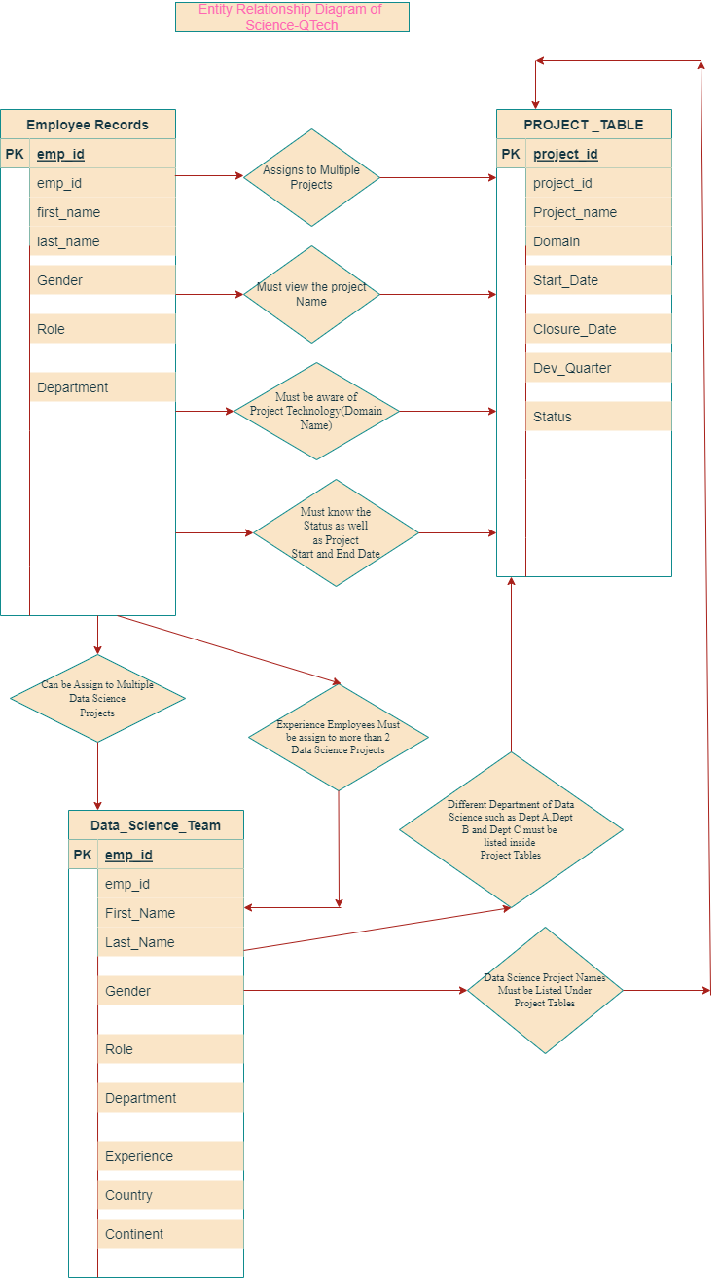

Q3)Write a query to fetch EMP_ID, FIRST_NAME, LAST_NAME, GENDER, and DEPARTMENT from the employee record table, and make a list

of employees and details of their department.

Ans) use employee;

show tables;

select * from emp_record_table;

select emp_id,first_name,last_name,gender,dept from emp_record_table order by dept;

Q4) Write a query to fetch EMP_ID, FIRST_NAME, LAST_NAME, GENDER, DEPARTMENT, and EMP_RATING

if the EMP_RATING is:

less than two

greater than four

between two and four

Ans) use employee;

select * from emp_record_table;

select emp_id,first_name,last_name,gender,dept,emp_rating from emp_record_table where emp_rating<2;

select emp_id,first_name,last_name,gender,dept,emp_rating from emp_record_table where emp_rating >4;

select emp_id,first_name,last_name,gender,dept,emp_rating from emp_record_table where emp_rating between 2 and 4;

Q5) Write a query to concatenate the FIRST_NAME and the LAST_NAME of employees in the Finance department from the employee table

and then give the resultant column alias as NAME.

Ans) select concat(first_name,last_name) as Name from emp_record_table

where DEPT="Finance";

Q6)Write a query to list only those employees who have someone reporting to them.

Also, show the number of reporters (including the President)

Ans) select * from emp_record_table;

select emp_id,first_name,last_name,PROJ_ID,MANAGER_ID from emp_record_table

where PROJ_ID is not Null and MANAGER_ID is not Null;

select role,count(role) as Number_of_reporters from

emp_record_table

group by role;

Q7) Write a query to list down all the employees from the healthcare and finance departments using union.

Take data from the employee record table.

Ans) use employee;

select * from emp_record_table;

select first_name,last_name from emp_record_table

where dept="HealthCare"

union

select first_name,last_name from emp_record_table

where dept="Finance";

Q8) Write a query to list down employee details such as EMP_ID, FIRST_NAME, LAST_NAME, ROLE, DEPARTMENT, and EMP_RATING grouped by dept. Also include the respective employee rating

along with the max emp rating for the department.

Ans) use employee;

select emp_id,first_name,last_name,

role,dept,emp_rating from emp_record_table

order by dept;

select max(emp_rating),dept

from emp_record_table

group by dept;

Q9) Write a query to calculate the minimum and the maximum salary of the employees in each role.

Take data from the employee record table.

Ans) use employee;

select min(salary) as Minimum_Salary,max(salary) as Maximum_Salary,role

from emp_record_table

group by role;

Q10) Write a query to assign ranks to each employee based on their experience.

Take data from the employee record table.

Ans) use employee;

select * from emp_record_table;

drop procedure if exists empexp;

Delimiter $$

create procedure empexp(in empx bigint, out eranks varchar(100))

begin

declare myexp bigint default 1;

select exp into myexp from emp_record_table where exp=empx;

if myexp between 1 and 2 then

set eranks="Junior Data Scientist";

elseif myexp between 3 and 5 then

set eranks="Associate Data Scientist";

elseif myexp between 6 and 9 then

set eranks="Senior Data Scientist";

elseif myexp between 11 and 12 then

set eranks="Lead Data Scientist";

elseif myexp between 13 and 15 then

set eranks="Manager";

elseif myexp=20 then

set eranks="President";

else

set eranks="Not Applicable";

end if;

end $$

call empexp(13,@eranks);

select @eranks;

Q11) Write a query to create a view that displays employees in various countries whose salary is

more than six thousand.

Take data from the employee record table.

Ans) use employee;

select * from emp_record_table;

create view emprecordsalary

as select first_name,last_name,salary from emp_record_table

where salary>6000;

select * from emprecordsalary;

Q12) Write a nested query to find employees with experience of more than ten years.

Take data from the employee record table.

Ans) use employee;

select * from emp_record_table;

select first_name,last_name,exp from emp_record_table

where exp=(select exp from emp_record_table where exp>10);

select first_name,last_name,exp from

emp_record_table where exp>10;

create view games

as select

first_name,last_name,exp from

emp_record_table where exp>10;

select * from games;

Q13) Write a query to create a stored procedure to retrieve the details of the employees whose experience is more than three years.

Take data from the employee record table.

Ans) use employee;

select * from emp_record_table;

Delimiter $$

create procedure getemployeedetails()

begin

select * from emp_record_table where exp >3;

end $$

call getemployeedetails();

Q14) Write a query using stored functions in the project table to check

whether the job profile assigned to each employee in the data science team matches the organization’s set standard.

The standard being:

For an employee with experience less than or equal to 2 years assign 'JUNIOR DATA SCIENTIST',

For an employee with the experience of 2 to 5 years assign 'ASSOCIATE DATA SCIENTIST',

For an employee with the experience of 5 to 10 years assign 'SENIOR DATA SCIENTIST',

For an employee with the experience of 10 to 12 years assign 'LEAD DATA SCIENTIST',

For an employee with the experience of 12 to 16 years assign 'MANAGER'.

Ans) use employee;

select * from emp_record_table;

Drop Function if exists Customer_occupation;

DELIMITER $$

CREATE FUNCTION Customer_Occupation(

exp int

)

RETURNS VARCHAR(100)

DETERMINISTIC

BEGIN

DECLARE customer_occupation VARCHAR(100);

IF exp <= 2 THEN

SET customer_occupation = 'Junior Data Scientist';

ELSEIF (exp <= 2 AND

exp >= 5) THEN

SET customer_occupation = 'Associate Data Scientist';

ELSEIF exp >= 5 and exp<=10 THEN

SET customer_occupation = 'Senior Data Scientist';

ELSEIF exp >= 10 and exp<=12 THEN

SET customer_occupation = 'Lead Data Scientist';

ELSEIF exp >= 12 and exp<=16 THEN

SET customer_occupation = 'Lead Data Manager';

END IF;

-- return the customer occupation

RETURN (customer_occupation);

END$$

SHOW FUNCTION STATUS WHERE db = 'employee';

SELECT first_name, last_name, Customer_Occupation(exp)

FROM emp_record_table

order by exp;

Q15-Create an index to improve the cost and performance of the query to

find the employee whose FIRST_NAME is ‘Eric’

in the employee table after checking the execution plan.

Ans) use employee;

desc emp_record_table;

alter table emp_record_table modify column first_name varchar(100);

create index ixs on employee.emp_record_table(FIRST_NAME);

show index from emp_record_table;

Q16)Write a query to calculate the bonus for all the employees,

based on their ratings and salaries

(Use the formula: 5% of salary * employee rating).

Ans) use employee;

alter table emp_record_table add column bonus_for_employee bigint ;

alter table emp_record_table drop column bonus_for_employee;

/* Syntax of Update While calculating bonus */

update emp_record_table set bonus_for_employee=0.05*16500*5

where emp_id="E001";

update emp_record_table set bonus_for_employee=0.05*8500*3

where emp_id="E005";

update emp_record_table set bonus_for_employee=0.05*9000*2

where emp_id="E010";

update emp_record_table set bonus_for_employee=0.05*5500*5

where emp_id="E052";

update emp_record_table set bonus_for_employee=0.05*7700*1

where emp_id="E057";

update emp_record_table set bonus_for_employee=0.05*9500*5

where emp_id="E083";

update emp_record_table set bonus_for_employee=0.05*10500*4

where emp_id="E103";

update emp_record_table set bonus_for_employee=0.05*7500*5

where emp_id="E204";

update emp_record_table set bonus_for_employee=0.05*6500*2

where emp_id="E245";

update emp_record_table set bonus_for_employee=0.05*7000*3

where emp_id="E260";

update emp_record_table set bonus_for_employee=0.05*5000*3

where emp_id="E403";

update emp_record_table set bonus_for_employee=0.05*11000*4

where emp_id="E428";

update emp_record_table set bonus_for_employee=0.05*5000*2

where emp_id="E505";

update emp_record_table set bonus_for_employee=0.05*4300*1

where emp_id="E532";

update emp_record_table set bonus_for_employee=0.05*1000*2

where emp_id="E583";

update emp_record_table set bonus_for_employee=0.05*8500*4

where emp_id="E612";

update emp_record_table set bonus_for_employee=0.05*3000*1

where emp_id="E620";

update emp_record_table set bonus_for_employee=0.05*2800*4

where emp_id="E640";

select * from emp_record_table;

Q17) Write a query to calculate the average salary distribution

based on the continent and country. Take data from the employee record table.

Ans) use employee;

select * from emp_record_table;

/* Average Salary Distribution Query */

select avg(salary) from emp_record_table as AverageSalaryDistribution1

where continent="North America" and Country="USA";

select avg(salary) from emp_record_table as AverageSalaryDistribution2

where continent="North America" and Country="Canada";

select avg(salary) from emp_record_table as AverageSalaryDistribution3

where continent="Europe" and Country="Germany";

select avg(salary) from emp_record_table as AverageSalaryDistribution4

where continent="South America" and Country="Colombia";

select avg(salary) from emp_record_table as AverageSalaryDistribution5

where continent="Europe" and Country="France";

select avg(salary) from emp_record_table as AverageSalaryDistribution6

where continent="Asia" and Country="India";